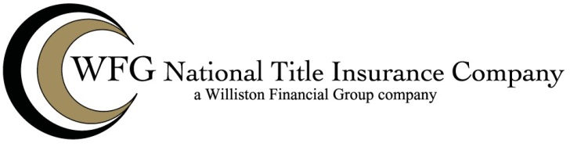

REVOLVING LINE OF CREDIT ENDORSEMENT

This endorsement is an addition or amendment to the policy or commitment of WFG National Title Insurance Company identified as follows:
INSURED |  | POLICY/COMMITMENT NO.
SECTION AMENDED | EFFECTIVE DATE OF ENDORSEMENT | BEING PAGE | OF PAGES

WFG NATIONAL TITLE INSURANCE COMPANY (HEREIN CALLED “THE COMPANY”)

The Company insures the insured against loss or damage arising from failure of the following assurances to be true:
Advances made subsequent to the Date of Policy and in accordance with the terms of the Insured Mortgage providing security for credit line advances and during the term provided for the credit line advances will be secured by the Insured Mortgage with the same priority over liens, encumbrances and the rights of purchasers for value without notice that this Policy insures to exist for amounts secured by the Insured Mortgage which were advances prior to the Date of Policy.

The insurance provided by this Endorsement is not subject to Paragraph 3.(d) of the Exclusions from Coverage and Section 8(d)(i) of the Conditions and Stipulations of this Policy to the extent that it is inconsistent with them.

The insurance provided by this Endorsement is subject to the following provisions:

- Every advance purporting to be made pursuant to the Insured Mortgage which, together with all other indebtedness and sums secured by it, (i) exceeds the maximum principal amount to be outstanding at any time as stated in the Insured Mortgage, or (ii) exceeds the Amount of Policy stated in Schedule A of this Policy, is excluded from the assurances of this Endorsement.

- Losses due to the following matters which arise, occur or attach to the title to the land or affect the Insured Mortgage after Date of Policy are excepted from the insurance provided by this Endorsement:

  - Taxes, assessments, costs, charges, damages and other obligations to the government secured by statutory liens;

  - The effect of any bankruptcy affecting the estate or interest of the debtors or any present or future holders of any interest in the title to the land;

  - Liens, encumbrances, conveyances and other matters actually known to the insured prior to the advance if the advance is made subsequent to the occurrence of a default (of which the Insured has actual knowledge) under the terms of the Insured Mortgage and prior to the cure of the default.

The total liability of the Company under said Policy and any endorsements thereof shall not exceed, in the aggregate, the Amount of Policy stated in Schedule A and costs, attorney's fees and expenses which the Company may become obligated to pay by the terms of the Conditions and Stipulations of this Policy.

This Endorsement is made a part of the Policy and is subject to all the terms and provisions thereof and all prior endorsements thereto. Except to the extent expressly stated herein, this Endorsement does not modify any of the terms and provisions of the Policy and does not change the Date of the Policy or increase the Amount of Policy shown in Schedule A. This Endorsement is subject to and does not modify the Exceptions from Coverage in the Policy and terms of any Endorsements to the Policy.

WFG NATIONAL TITLE INSURANCE COMPANY

By Authorized Signatory

